Use Case 1: Add money to the balance

Step 1. User opens the app.

Step 2. The app shows the UI.

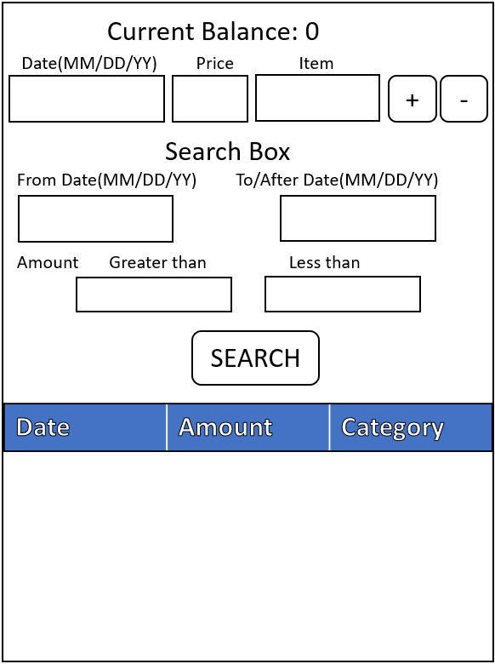

Step 3. User enters the content and click “+” button.

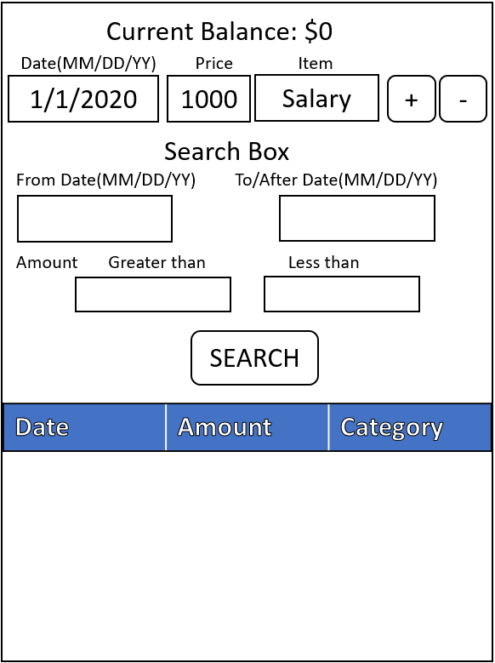

Step 4. The app updates the current balance and shows the transaction in the table.

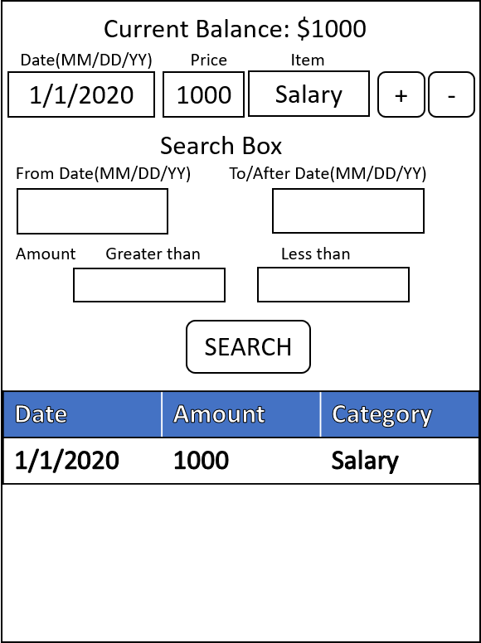

Use Case 2: Spend money from the account

Step 1. User opens the app.

Step 2. The app shows the current balance and history from last time.

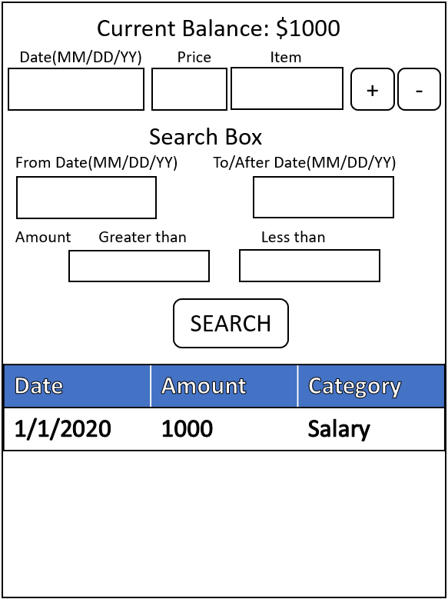

Step 3. User enters the content and click “-” button.

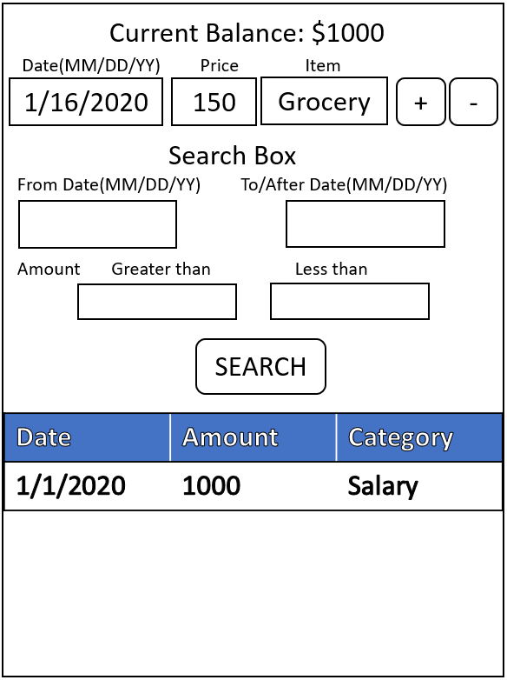

Step 4. The app updates the current balance and shows the transaction in the table.

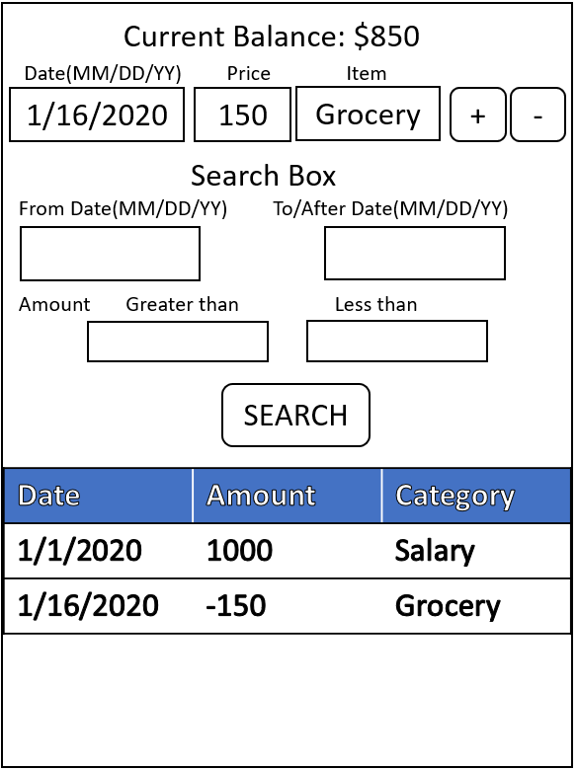

Use Case 3: Search for all the spending transactions

Step 1. User opens the app.

Step 2. The app shows the current balance and history from last time.

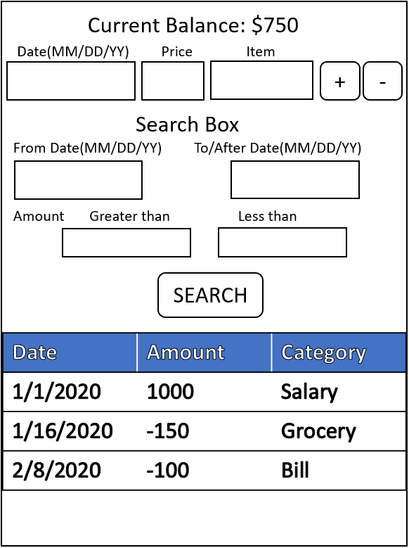

Step 3. User enters the 0 in the “Less than” box and click “SEARCH” button.

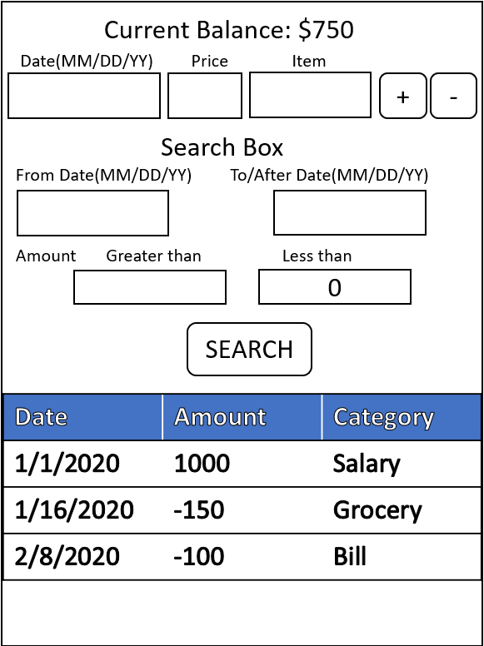

Step 4. The app shows only the spending transactions in the table.

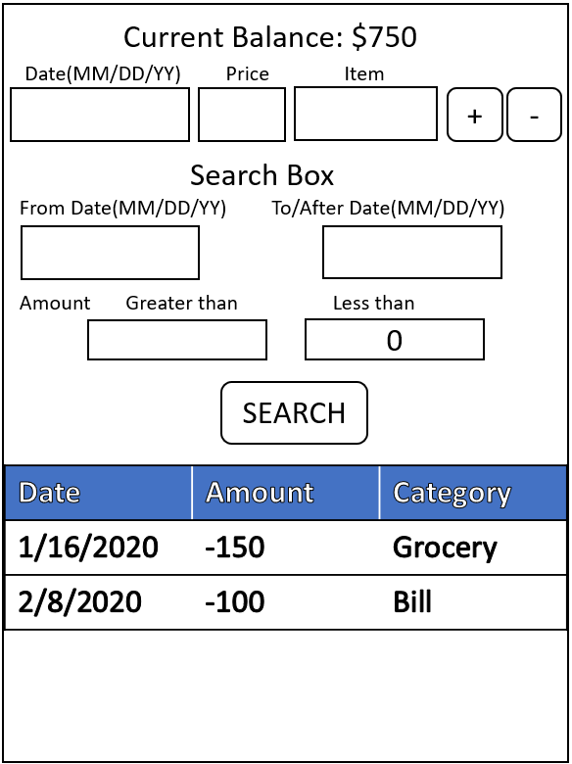

Use Case 4: Search for all the transactions from 2/1/2020 to 2/15/2020

Step 1. User opens the app.

Step 2. The app shows the current balance and history from last time.



Step 3. User enters the 2/1/2020 in the “From Date” box and 2/15/2020 in the To/After box and then click “SEARCH” button.

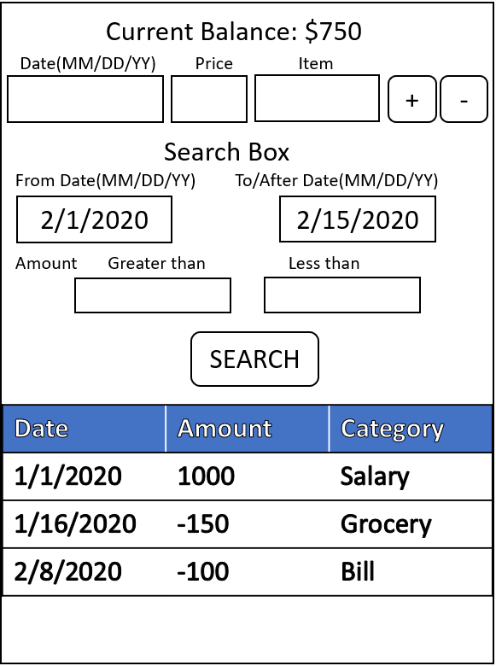

Step 4. The app shows only the transactions during this time period in the table.

